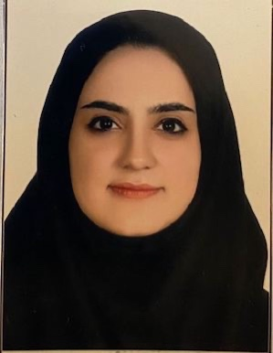

**Name**: Dr. Zohreh Halimi Tabrizi

**Academic position**: Assistant professor at Pediatric Dentistry Department, Dentistry Faculty, Tabriz University of Medical Science.

**Place and date of birth**: 3 May 1994, Tabriz

**Latest degree received**:

Department of pediatric dentistry and hospital dentistry

Faculty of dentistry, Tabriz University of Medical Sciences, Daneshgah Ave. Tabriz, Iran

<Tel:+984133355967-70>

Fax:+984133346977

Email : **Zohreh7hlm@gmil.com**

**Educations**:

**Undergraduate education:**

2012- 2012: Doctorate of Dental Surgery (DDS) at Faculty of dentistry, Tabriz University of Medical Sciences

**Post graduate education**:

2012-2018: Pediatric Dentistry Residency

2021: Board certified in Pediatric Dentistry

**Academic and administrative positions:**

1. 2021-now. Assistant professor at Pediatric Dentistry Department, Dentistry Faculty, Tabriz University of Medical Science.
2. 2021- now. Member of EDO at Tabriz University of Medical Science.

**Teaching responsibilities:**

1-2021- now: Theoretical and practical education of undergraduate students in dentistry at Pediatric Dentistry Department, Dentistry Faculty, Tabriz University of Medical Science.

2- 2021- now: Theoretical education of postgraduate students in pediatric dentistry at Pediatric Dentistry Department, Dentistry Faculty, Tabriz University of Medical Science.

**Publications:**

1- Aminabadi NA, Golsanamlou O, Halimi Z, Jamali Z. Assessing the Different Levels of Virtual Reality That Influence Anxiety, Behavior, and Oral Health Status in Preschool Children: Randomized Controlled Clinical Trial. JMIR Perioper Med. 2022 Apr 18;5(1):e35415. doi: 10.2196/35415. PMID: 35436233; PMCID: PMC9062716.

2- Aslaminabadi N, Halimi Tabrizi Z, Golsanamlou O, Estaki Z, Jamali Z. Bond strength of conventional versus modified methods for Class IV restorations in primary incisors: An in vitro study. J Dent Res Dent Clin Dent Prospects. 2022 Spring;16(2):123-129. doi: 10.34172/joddd.2022.021. Epub 2022 Oct 15. PMID: 36561382; PMCID: PMC9763657.

3- Taghiloo H, Halimi Z. The frequencies of different types of nasal septum deviation and their effect on increasing the thickness of maxillary sinus mucosa. J Dent Res Dent Clin Dent Prospects. 2019 Summer;13(3):208-214. doi: 10.15171/joddd.2019.032. Epub 2019 Oct 7. PMID: 31857867; PMCID: PMC6904919.

**Research interests**:

* Preventive dentistry
* Pulp therapy for primary teeth
* Fissure sealant therapy